ABE598 Autonomous Decision Making: Problem Set 2

# Problem 1 – Regression Problem with Wing Rock Dynamics

## Part 1. Collect a dataset

I took data for a simulation time of 5 seconds from 5 different initial conditions using the file wingrock_main.m.

%sim1

x = [1.2 ;1];

%sim2

x = [3; .6];

%sim3

x = [5; 1];

%sim4

x = [.3; 1.3];

%sim5

x = [3.8; 0.5];

These data were then stored in CSV files for later use.

## Part 2. Learn weights using non-linear regression using the basis provided

Using the basis provided, hw1_1_1 uses Matlab’s built-in regression function to find the basis weights to be:

blearned = [ 0.7990 0.2323 0.6891 -0.6239 0.0134 0.0214]

Compared to the actual weights, we can see that the learned values and the actual values are close.

bactual = [.8 .2314 .6918 -.6245 .0095 .0214]

## **Part 3. Use online GP and Validate**

Using the same data as above, the file hw1_1_3.m find the estimated state given input data to learn. The MSE between the predicted state and the actual state depends on the range over which x1 and x2 are evaluated. The best predictions occur when the range is small, due to the relatively limited amount and variety of data put into the GP model. Therefore, when the ranges are set at

x1_range = min(X1_IN):.1:max(X1_IN);

x2_range = min(X2_IN):.1:max(X2_IN);

the MSE = 1.9321, and the resulting figures are

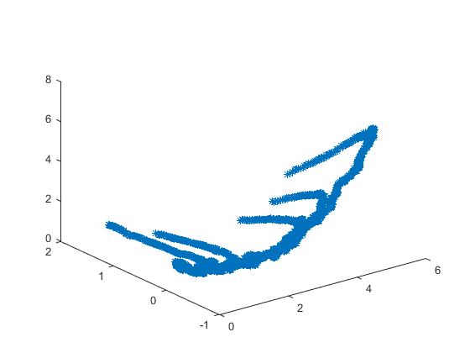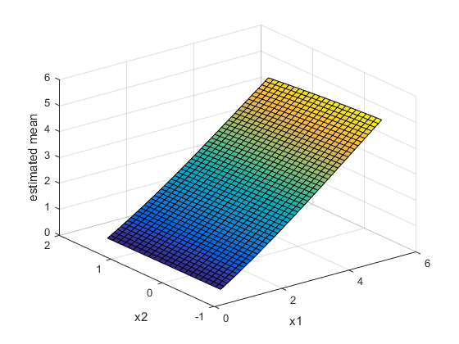

For a plot over a larger range

x1_range = -20:1:20;

x2_range = -20:1:20;

The MSE becomes significantly worse, at MSE = 1.1628e+04, and the figure the program generates looks like the following

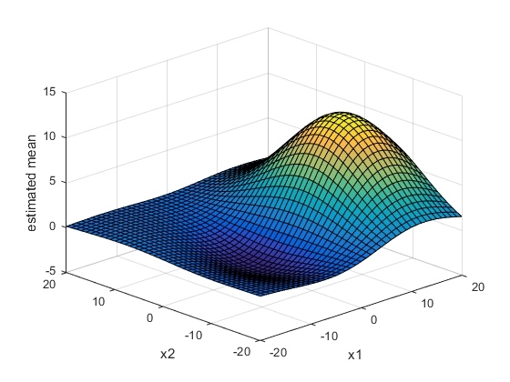

## Part 5. Plot the time histories of the predicted and true states

Plotting the estimated pDot and pDot predicted by the model, we get the following:

What’s this??

# Problem 2 – Clustering with K-Means

Over 20 runs, the algorithm implemented takes an average of 25.2389 seconds to run. The algorithm almost always converged to the correct clusters, as shown in the histogram over 51 runs.

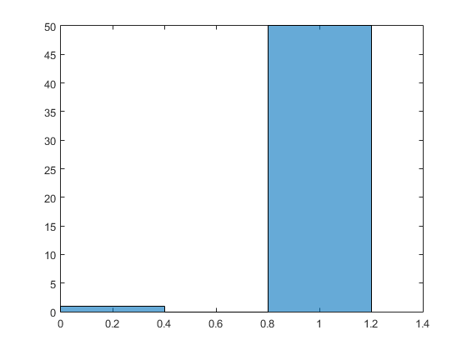

The figure below shows an example of the excellent convergence properties of the algorithm.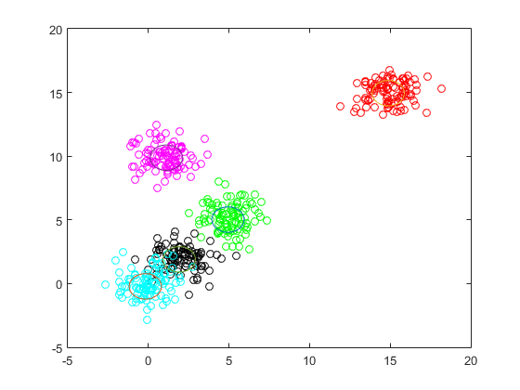

# Problem 3 – Dirichlet Means

# Problem 4 – Neural Networks

# Problem 5 – Deep Neural Network